

ecommerce project

**Deleiverable 2**



**21f_9236**

**21F-9646**

**22F-3371**

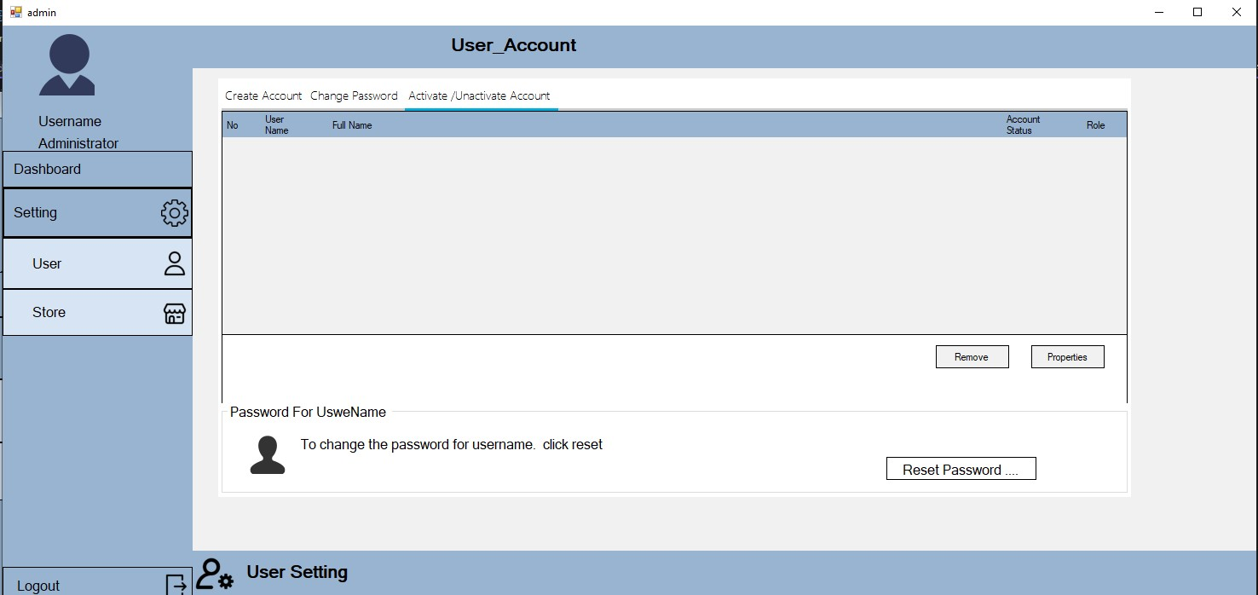Admin:

using System;

using System.Collections.Generic;

using System.ComponentModel;

using System.Data;

using System.Drawing;

using System.Linq;

using System.Text;

using System.Threading.Tasks;

using System.Windows.Forms;

namespace WindowsFormsApp1

{

public partial class eShop : Form

{

public eShop()

{

InitializeComponent();

}

}

}

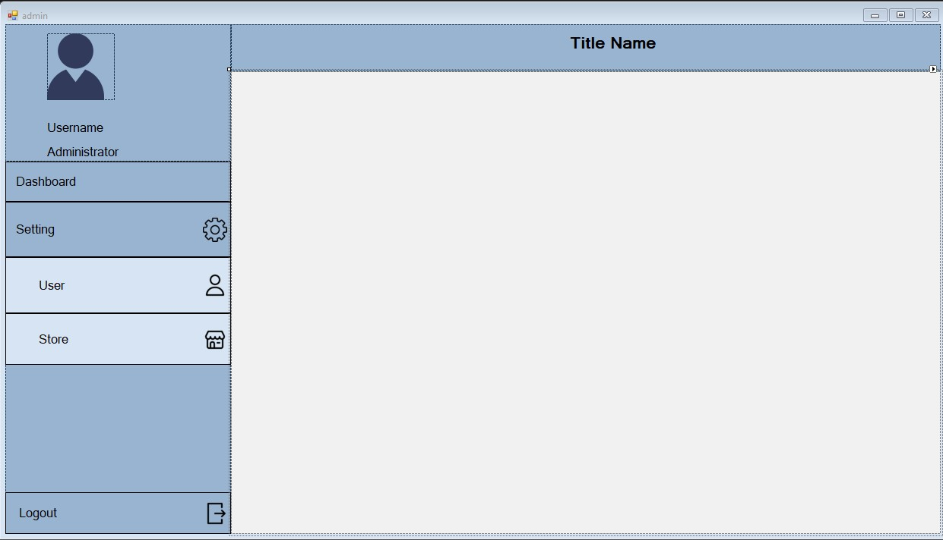

**User:**

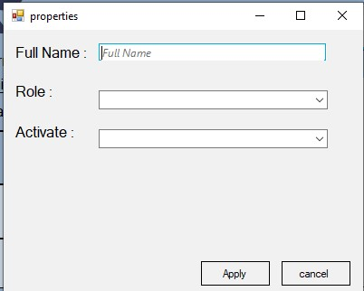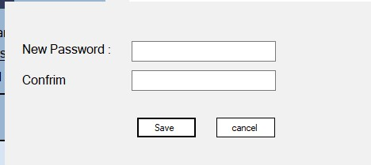

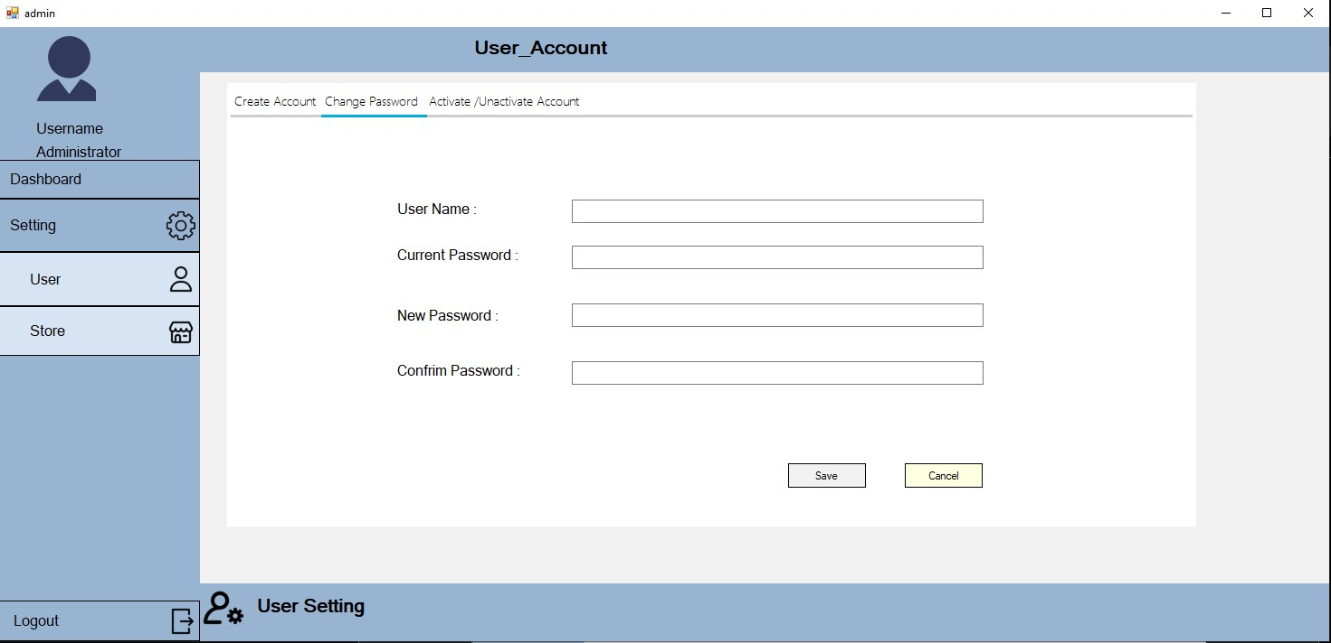

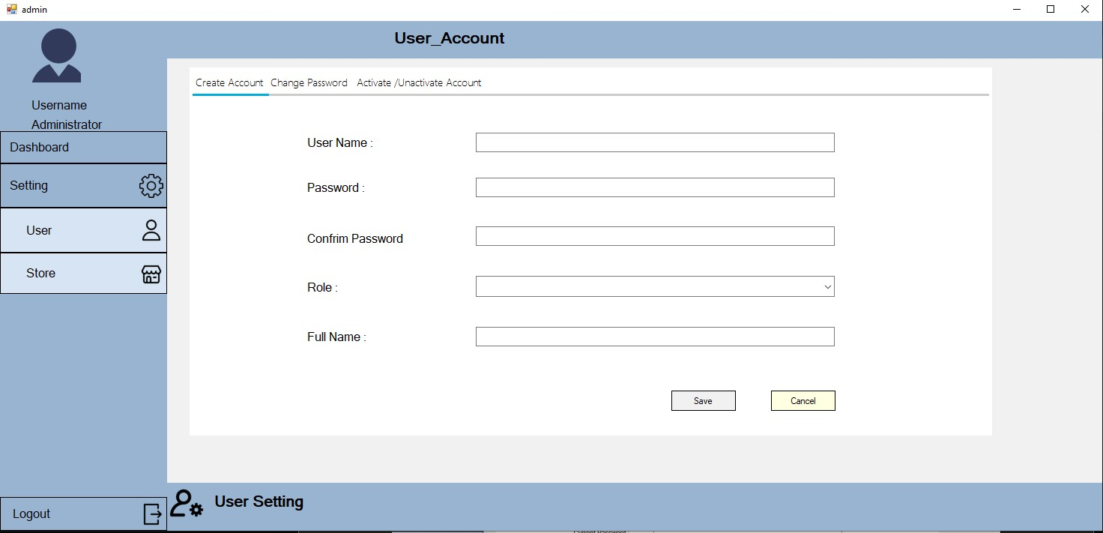

Manager:

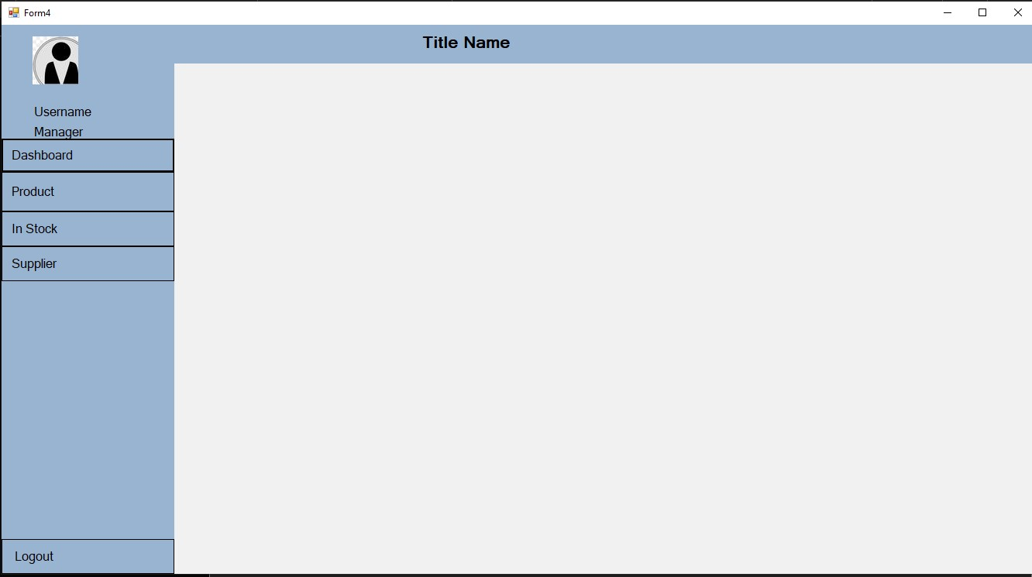

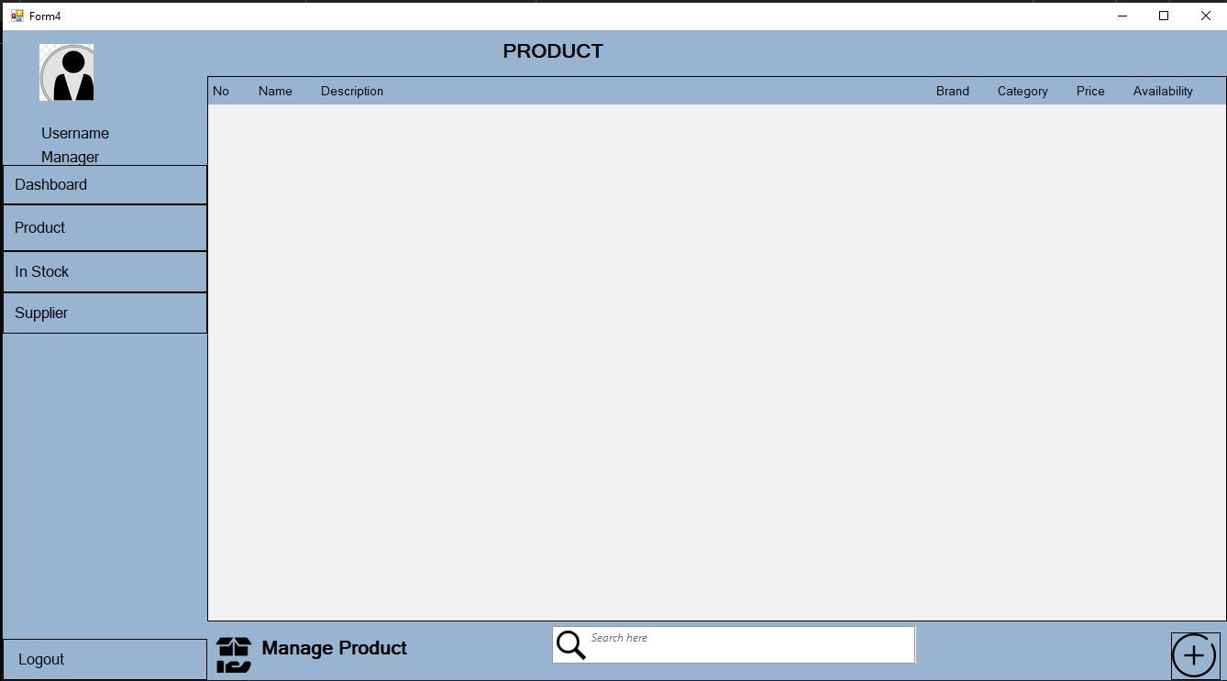

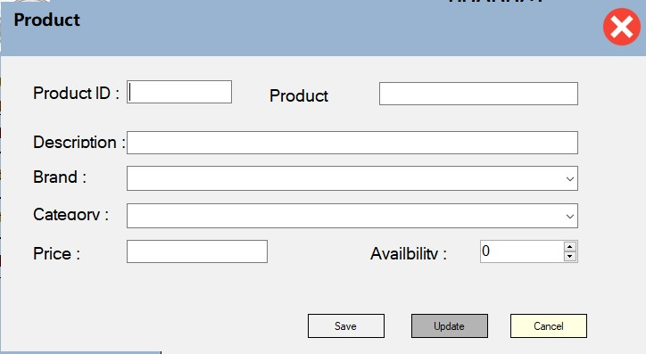

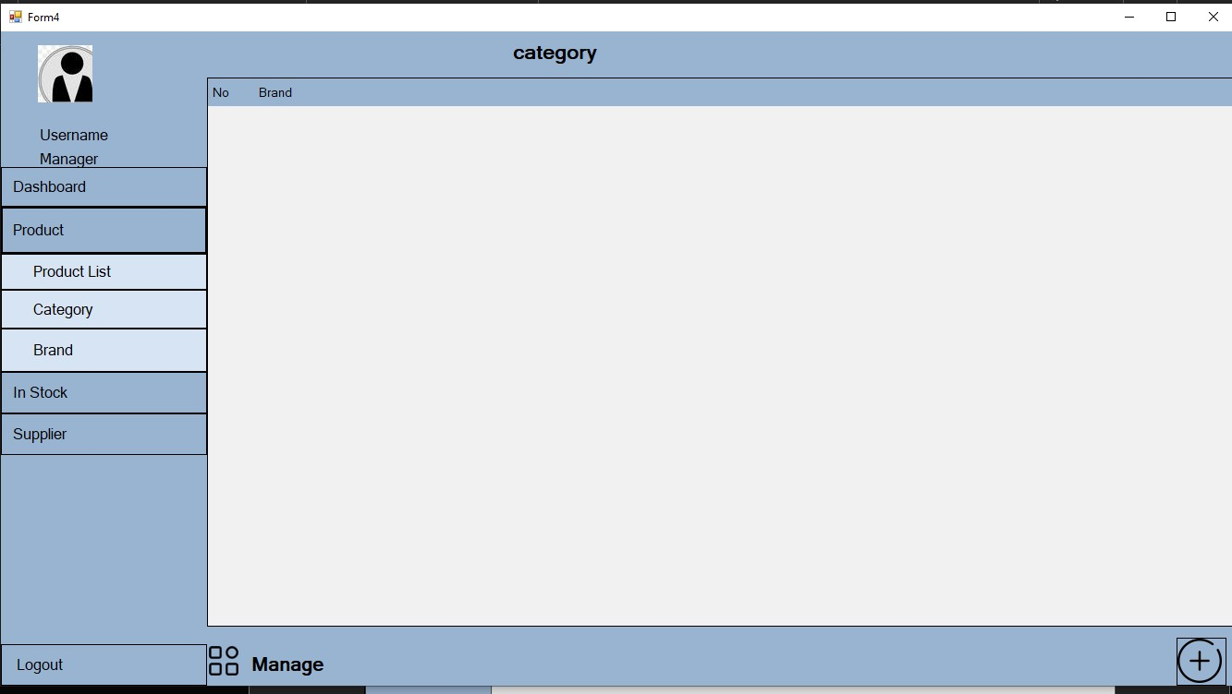

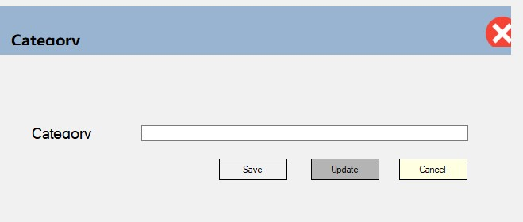

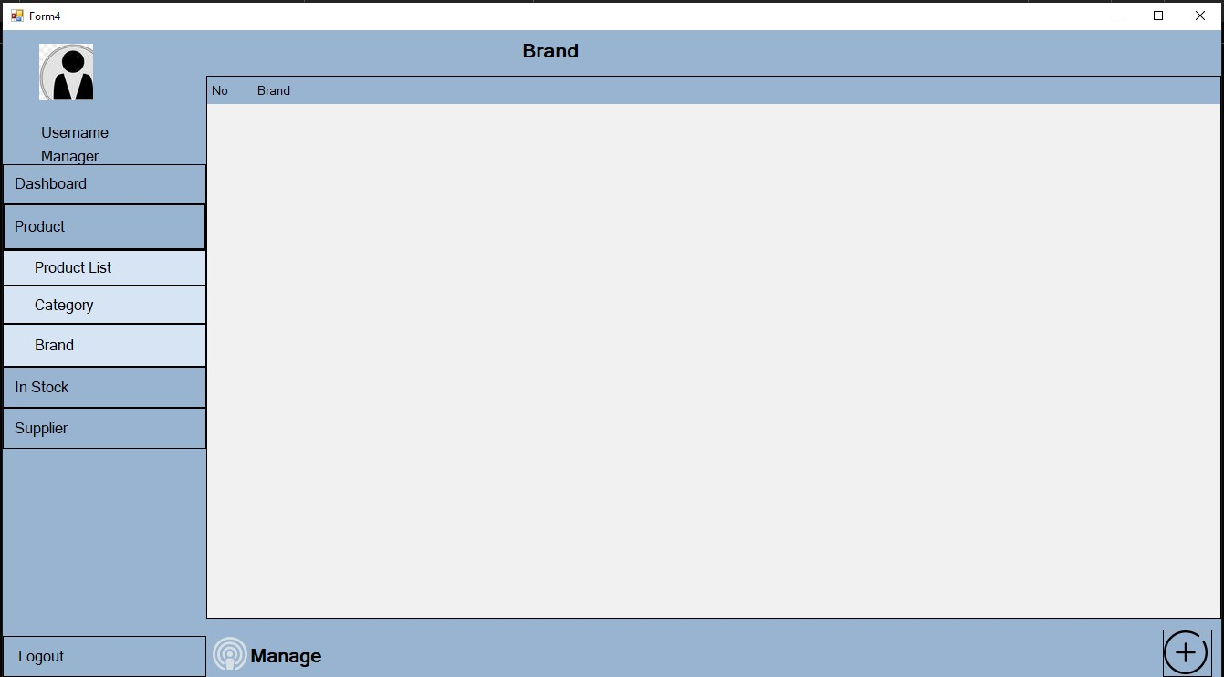

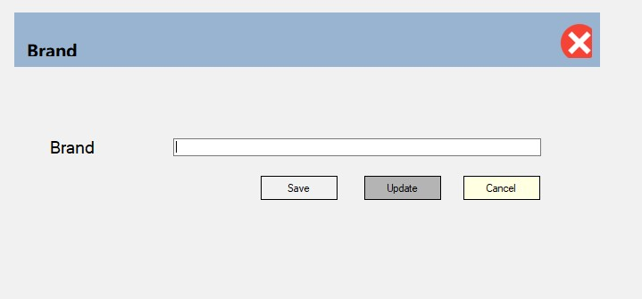

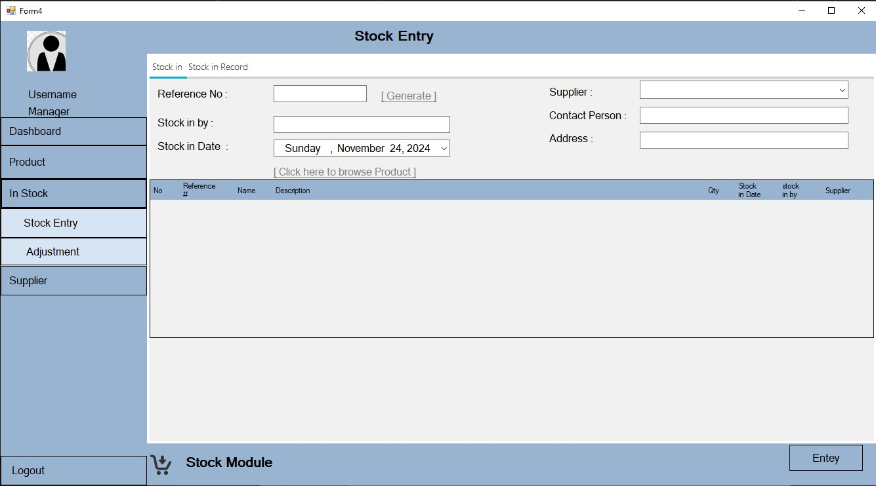

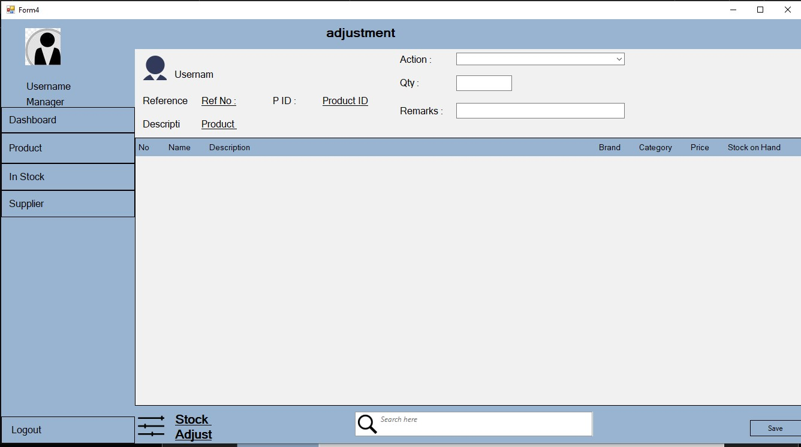

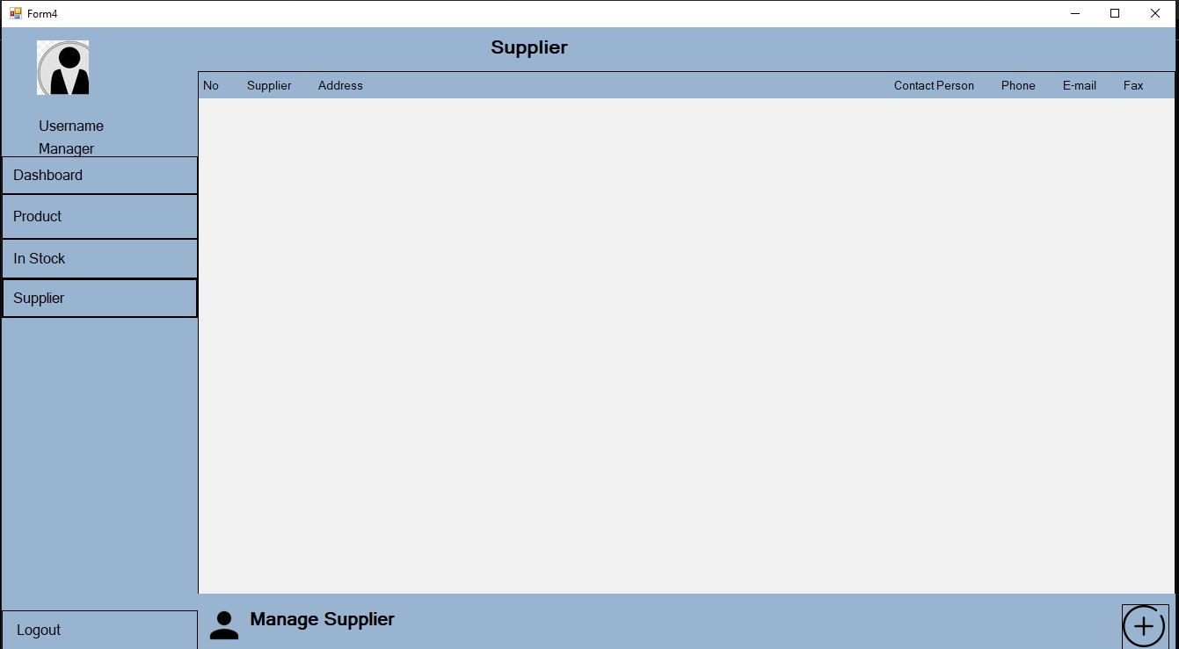

Cashir:

using System;

using System.Collections.Generic;

using System.ComponentModel;

using System.Data;

using System.Drawing;

using System.Linq;

using System.Text;

using System.Threading.Tasks;

using System.Windows.Forms;

namespace WindowsFormsApp1

{

public partial class Cashier : Form

{

public Cashier()

{

InitializeComponent();

}

}

}

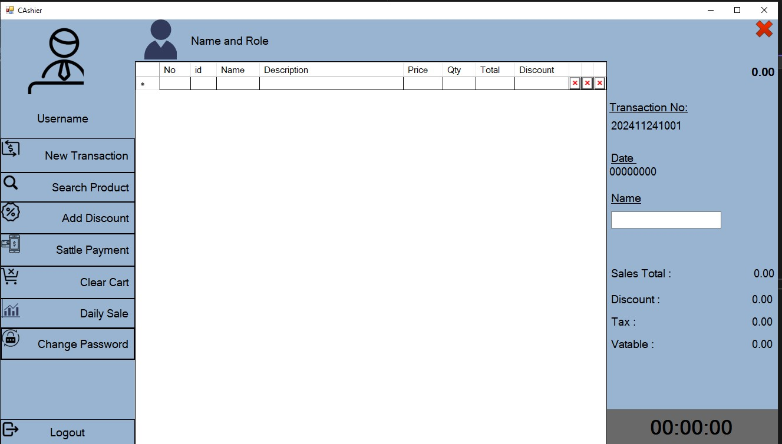

User :

using System;

using System.Collections.Generic;

using System.ComponentModel;

using System.Data;

using System.Drawing;

using System.Linq;

using System.Text;

using System.Threading.Tasks;

using System.Windows.Forms;

namespace WindowsFormsApp1

{

public partial class User_Account : Form

{

public User_Account()

{

InitializeComponent();

}

public void clear()

{

fullnametxt.Clear();

passwordtxt.Clear();

confrimpasswordtxt.Clear();

rolebox.Text = "";

fullnametxt.Focus();

usernametext.Clear();

Savebtn.Enabled = true;

cancelbtn.Enabled = false;

}

private void passwordtxt_TextChanged(object sender, EventArgs e)

{

}

private void label2_Click(object sender, EventArgs e)

{

}

private void label1_Click(object sender, EventArgs e)

{

}

private void textBox3_TextChanged(object sender, EventArgs e)

{

}

private void changecancelbtn_Click(object sender, EventArgs e)

{

clear();

}

}

}

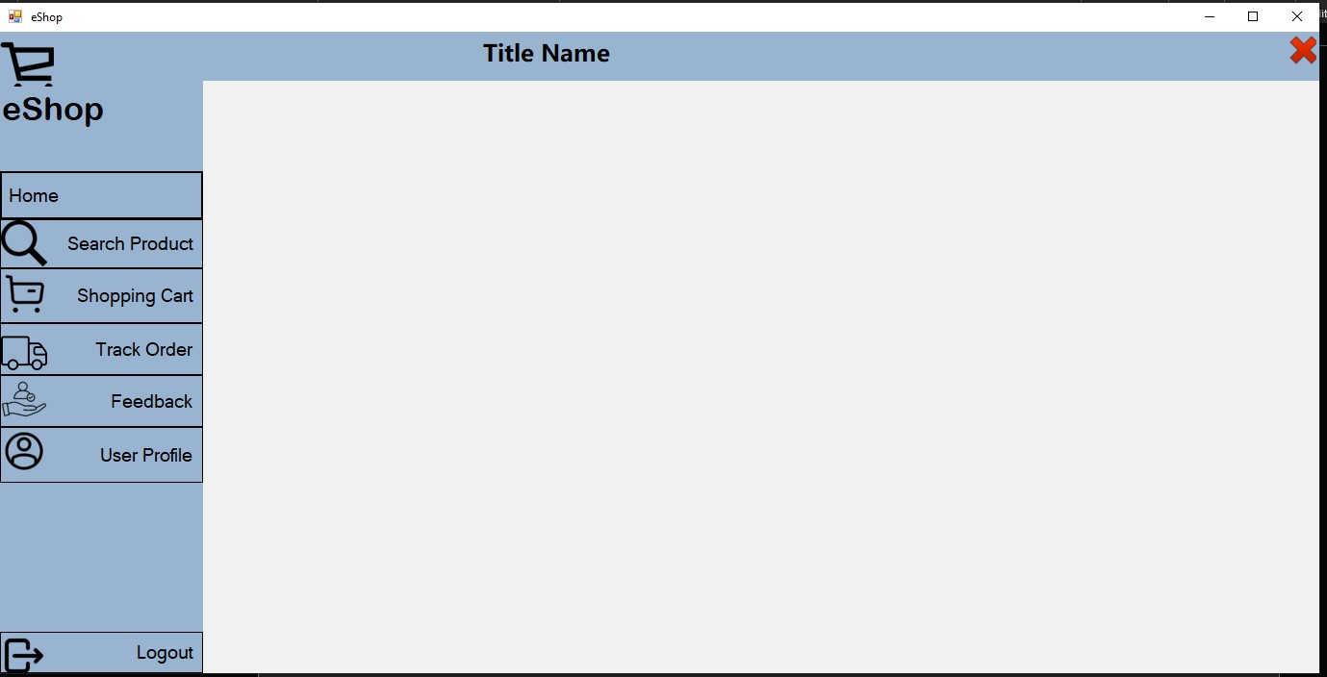

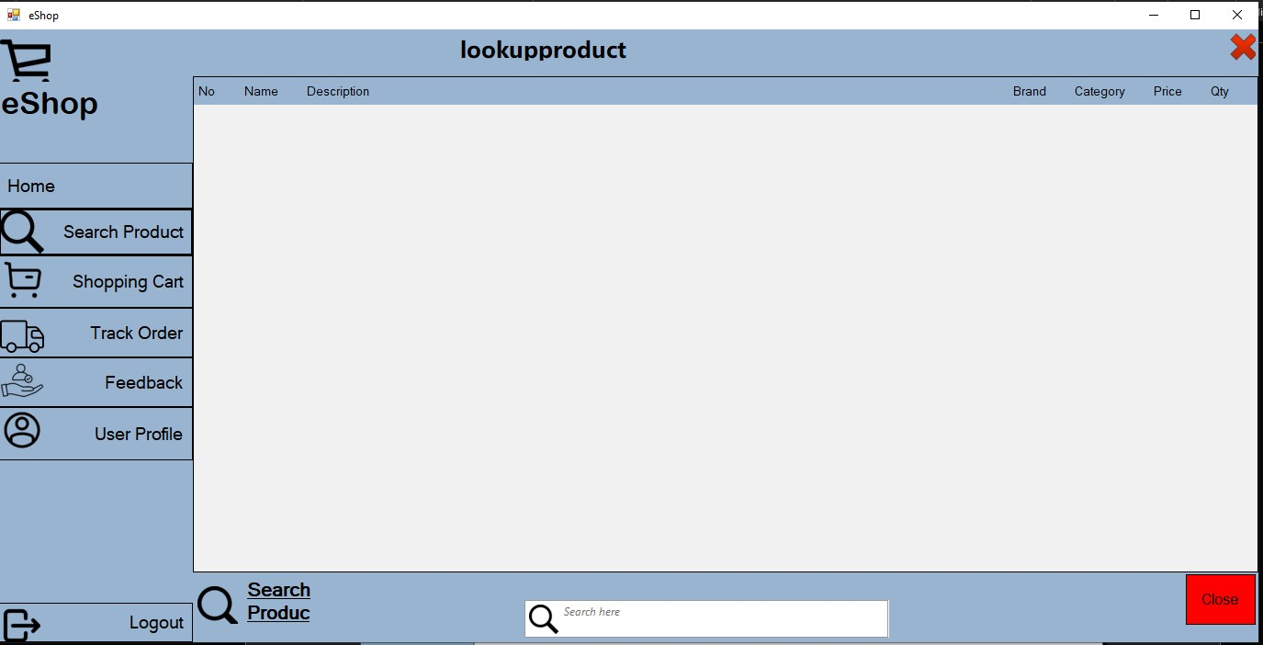

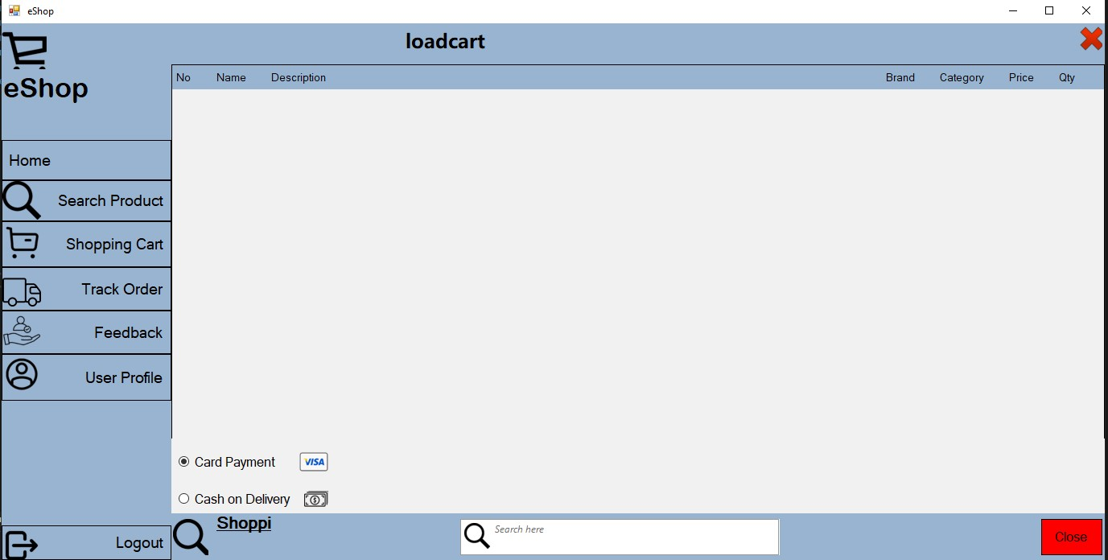

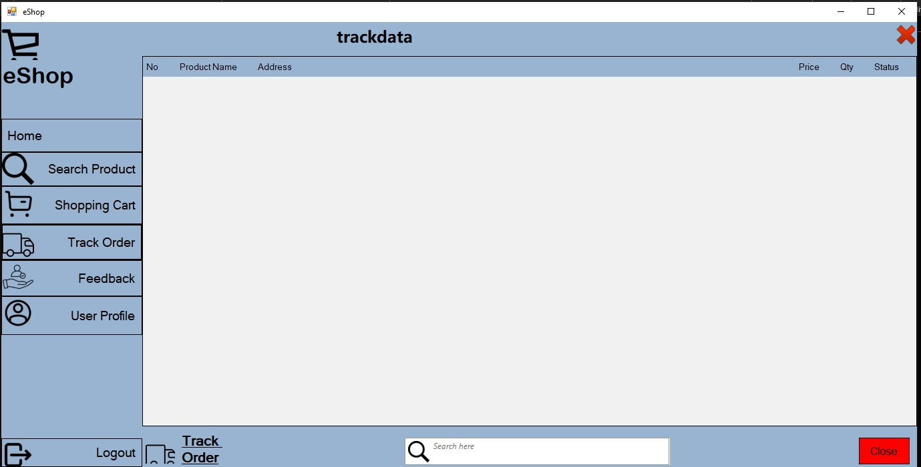

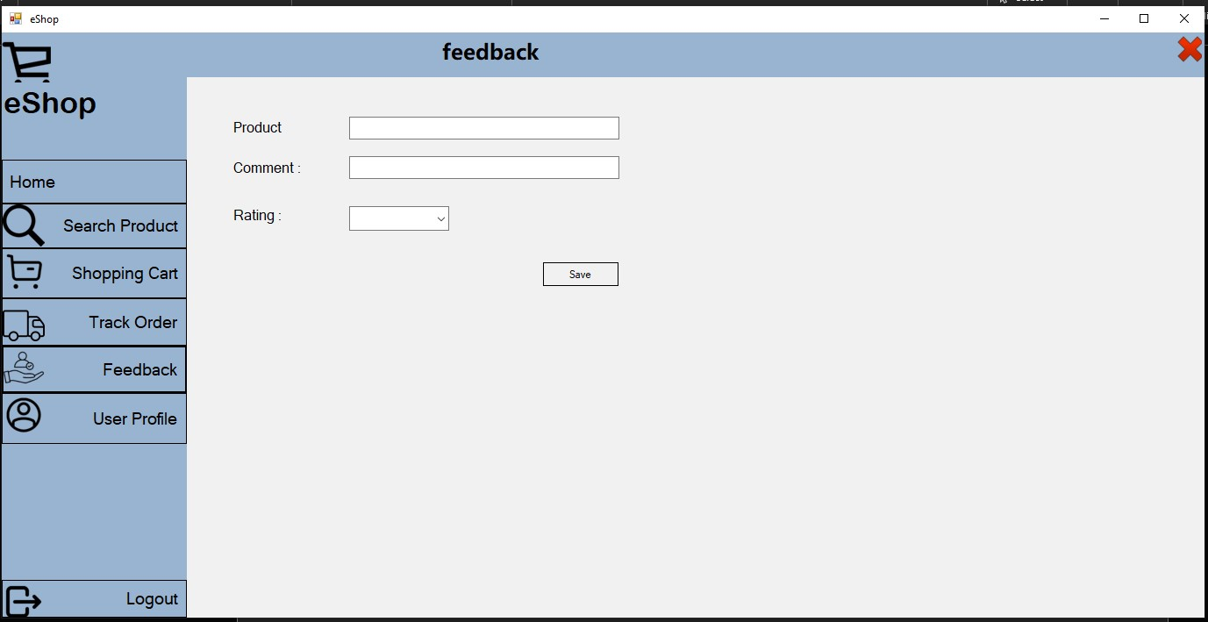

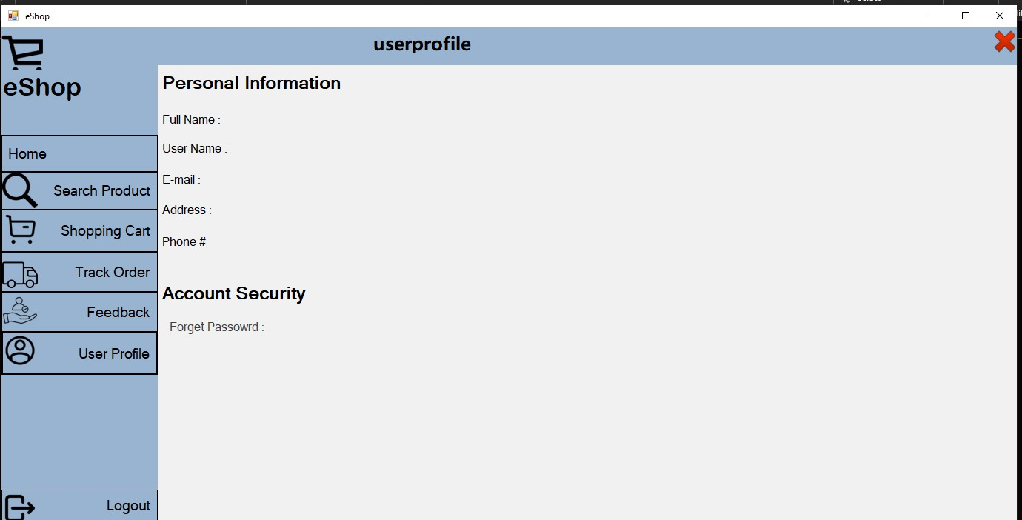

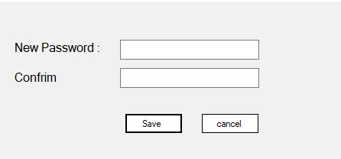

Login page:

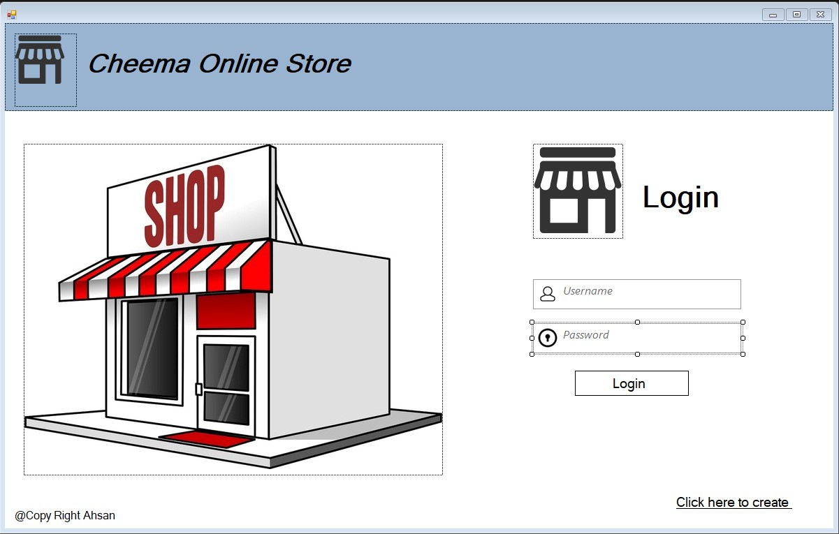

Sign up

